
(Autonomous Batch)
END SEMESTER SUPPLEMENTARY EXAMINATIONS (AR23), SEP – 2026

U.G. | Common to all |  | Degree | Bachelor of Technology
Academic Year | 2026-2027 |  | Sem. | 2nd
Course Code | 23BEX04 | Course Title
Course Code | 23BEX04 | ENGINEERING GRAPHICS
Duration | 90 Min. | Maximum Marks |  |  | 35 (Thirty Five)

SECTION-I
Conventional Drawing

No | Questions | RBT Level | COs | Marks
1 | Draw a parabola when the distance between its focus and directrix is 50mm. | Apply | 1 | 7M
OR
2 | The major and minor axes of an ellipse are 160mm and 120mm. Draw an ellipse by using concentric circles method. | Apply | 1 | 7M
3 | A line AB, 65 mm long, has its end A 20 mm above the HP and 25 mm in front of the VP. The end B is 40 mm above the HP and 65 mm in front of the VP. Draw the projections of AB and show its inclinations with the HP and the VP. | Apply | 2 | 14M
OR
4 | Draw the projections of a pentagonal plane base edge 30 mm and having its base edge on the HP and an edge of base perpendicular to the VP and plane is inclined at 30 degrees to HP. | Apply | 2 | 14M
5 | A square prism, base 40 mm side and height 65 mm, has its axis inclined at 45⁰ to the HP. And has an edge of its base, on the HP and inclined at 30⁰ to the VP. Draw its projections. | Apply | 3 | 14M
OR
6 | A hexagonal prism has one of its rectangular faces parallel to the HP. Its axis is perpendicular to the VP and 3.5 cm above the ground. Draw its projections when the nearer end is 2 cm in front of the VP. Side of the base 2.5 cm long; axis 5 cm long. | Apply | 3 | 14M

***********


SEMESTER END SUPPLEMENTARY EXAMINATIONS (AR23), SEP– 2026

U.G. | Common to all |  | Degree | Bachelor of Technology
Academic Year | 2026-2027 |  | Sem. | 2nd
Course Code | 23BEX04 | Course Title
Course Code | 23BEX04 | ENGINEERING GRAPHICS
Duration | 90 Min. | Maximum Marks |  |  | 35 (Thirty Five)

SECTION-II
Auto CAD Drawing

No | Questions | RBT Level | COs | Marks
7 | Draw the projections of a pentagonal prism, base 25 mm side and axis 50 mm long, resting on one of its rectangular faces on H.P., with the axis inclined at 45⁰ to V.P. | Apply | 4 | 7M
OR
8 | Draw the projections of a cylinder 75 mm diameter and 100 mm long, lying on the ground with its axis inclined at 30⁰ to the HP. and parallel to the VP. | Apply | 4 | 7M
9 | A cube side 30 mm is resting on its base on the H.P. with one of its face parallel to the V.P. Draw the development of the prism. | Apply | 5 | 14M
OR
10 | A square pyramid of base side 40 mm and axis 60 mm is resting on its base on the H.P. with a side of base parallel to the V.P. Draw its sectional views and true shape of the section, if it is cut by a section plane perpendicular to the V.P., bisecting the axis and is inclined at 45° to the H.P. | Apply | 5 | 14M
11 | Draw the Isometric view of the fig-1 shown in the following orthographic views and show the dimensions.  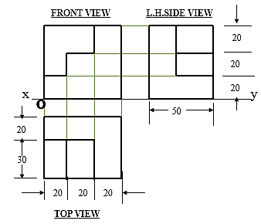  Fig-1 | Apply | 6 | 14M
OR
12 | Draw orthographic views (Front View, Top View and Side views) of the following orthographic views shown in Fig.2. Show the dimensions.  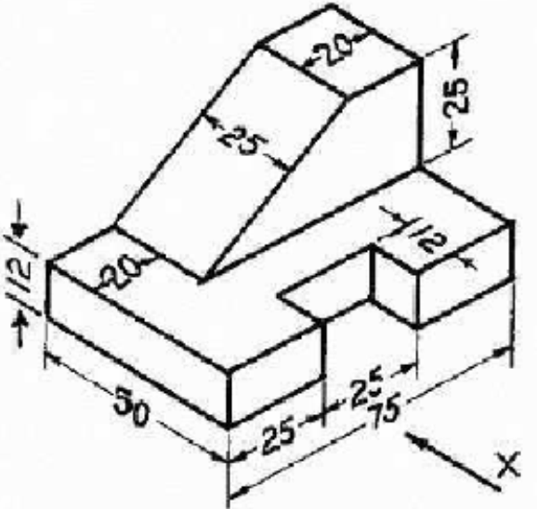 | Apply | 6 | 14M
***********

