
(Autonomous Batch)
SEMESTER END SUPPLEMENTARY EXAMINATIONS (AR20), SEP – 2026

U.G. | Civil Engineering |  | Degree | Bachelor of Technology
Academic Year | 2026-2027 |  | Sem. | IV
Course Code | 20CE404 | Course Title
Course Code | 20CE404 | Structural Analysis
Duration | 3 Hours | Maximum Marks |  |  | 60 (SIXTY)
SECTION-I
6 x 2 = 12 Marks
1.
No. | Questions (a to f) | RBT Level | COs
a | Define kinematic indeterminacy. | Remember | 1
b | Define resilience | Remember | 1
c | What are the advantages of fixed beam? | Remember | 3
d | What is the effect of sinking of a support in a continuous beam? | Remember | 3
e | Classify the arch based on its support. | Remember | 4
f | State Eddy’s theorem. | Remember | 4
SECTION-II
4 x 12 = 48 Marks

No | Questions (2 to 9) |  |  | RBT Level | COs | Marks
2 | (a) |  | Derive an expression for strain energy due to bending in a beam | Apply | 1 | 7M
2 | (b) |  | Analyse the truss shown in fig. All the members have same area of cross section and are of same material.  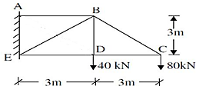 | Apply | 2 | 5M
OR
3 | (a) |  | A simply supported beam of length ‘L’ subjected to udl ‘w’ over entire span find the maximum deflection using Castigliano’s theorem. | Apply | 1 | 7M
3 | (b) |  | A propped cantilever of span 10m is fixed at one end and propped at the other end and carries a UDL of 12kN/m on its whole span. Calculate the prop reaction. | Apply | 2 | 5M
4 | (a) |  | A fixed beam of length 12M carries two point loads at a distance of 4M and 8M from left end respectively. Find the fixed end moments under the loads when the beam is simply supported. Draw the B.M.D. | Apply | 3 | 7M
4 | (b) |  | What is a propped cantilever? and find its degree of static and kinematic indeterminacy. | Understand | 2 | 5M
OR
5 | (a) |  | Using Clapeyron’s theorem, solve the problem of the continuous beam as shown in Figure EI is constant throughout  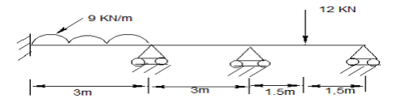 | Apply | 3 | 7M
5 | (b) |  | A propped cantilever beam of length 4m subjected to centre point load of 10kN determine the prop reaction and draw BMD. | Apply | 2 | 5M
6 | (a) |  | A symmetrical three hinged circular arch has a span of 13 m and a rise to the central hinge of 3 m. it carries a vertical load of 15 kN at 3 m from the left hand end. Find The reactions at the supports, Magnitude of the thrust at the springing, Bending moment, normal thrust and radial shear at 5 m from the left hand hinge. | Apply | 4 | 7M
6 | (b) |  | What are the basic unknowns in slope deflection method? Differentiate displacement and force method with an example. | Understand | 5 | 5M
OR
7 | (a) |  | A three hinged parabolic arch of span 25 m and rise 5 m carries an udl of 38 kN/m covering a distance of 10 m from left end. Find the horizontal thrust, the reactions at the hinges and the maximum negative moment.  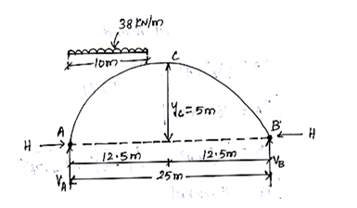 | Apply | 4 | 7M
7 | (b) |  | Analyse the two-span continuous beam loaded as shown in figure, by slope deflection method, if the moment of inertia of span AB is ‘I’ and the span BC is ‘3I’. Sketch the B.M.D.  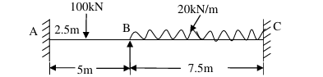 | Apply | 5 | 5M
8 | (a) |  | Analyze the continuous beam shown in fig. when the support ‘B’ settles by 30mm. Use Moment–Distribution method.  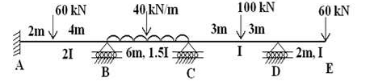 | Apply | 6 | 7M
8 | (b) |  | Derive slope-deflection equation with sinking support. | Apply | 5 | 5M
OR
9 |  | (a) | A two-span continuous beam ABC is fixed at A and simply supported at C. It is continuous over support B. The span AB = 4 m and span BC = 7 m. The span AB carries a uniformly distributed load (UDL) of 14 kN/m, and span BC carries a central point load of 12 kN. The flexural rigidity (EI) is constant for the whole beam. Find the support moments. | Apply | 6 | 7M
 |  | (b) | What are the conditions in which a frame is subjected to sway? | Understand | 5 | 5M
***********

